Bike Station Data Set – Dashboard Summary

Overview

This dashboard provides a complete analysis of bike stations, including total bike stands, available bikes, station status, utilization percentage, and station-wise performance. Interactive slicers are used to filter data by Address, Status, Bank, and Station Name for detailed insights.

Key Metrics
KPI | Description
Total Bike Stand | 3254 stands across all stations
Total Free Stands | 1716 free stands available
Utilization % | 0.04 overall utilization
Total Available Bikes | 114 bikes currently available

Dashboard Overview

Page1

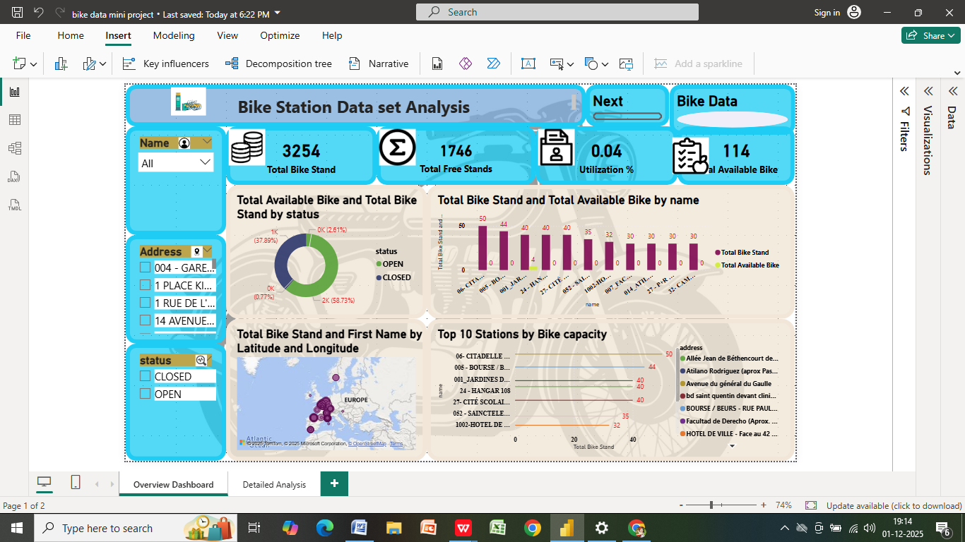

Page 2

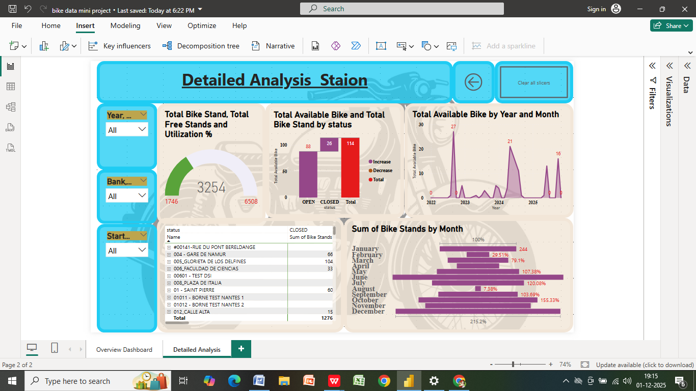

Main Highlights

1. Bike Stand Status
- Stations categorized as OPEN and CLOSED
- Donut chart shows proportion of bike stands by operating status

2. Geographical Analysis
- Map shows station locations using Latitude & Longitude
- Each marker represents the count of bike stands

3. Top Performing Stations
- Top 10 stations displayed based on Bike capacity
- Sorted bar chart highlights highest and lowest stand capacities

4. Available Bike Analysis
- Comparison between Total Available Bikes & Total Stands by Station Name

Detailed Analysis Page

Breakdown by Selected Filters
- Filters include Status, Bank, City, Station Name
- Allows deep-dive view per station or per bank

Year & Month Trend
- Line chart shows Total Available Bikes over time
- Helps identify seasonal trends and usage behaviour

Bike Stand and Utilization Comparison
- Column chart represents bike stand status counts (Open vs Closed)
- Shows performance difference between station categories

Navigation
- NEXT button on the overview page moves to detailed analysis
- BACK button returns to the overview dashboard

Conclusion
This dashboard efficiently visualizes bike-sharing operations, enabling better decisions on:
- Station capacity planning
- Bike demand forecasting
- Utilization performance monitoring
- Identifying high and low performing locations

Recommendation for Improvements
- Add forecasting for bike demand
- Add station revenue or cost metrics
- Add user demographic or trip duration if available

Prepared By
Created By : SATHYA B
Mentor : Nandhini Palanivel
Tool Used : Microsoft Power BI
Dataset Type: Bike Station Data Set

